Dictionary source: http: //s3.amazonaws.com/hw-sandbox/tutorial13/SentimentFiles.zip

Snapshot : Query log for loading data from twitter files into HIVE table

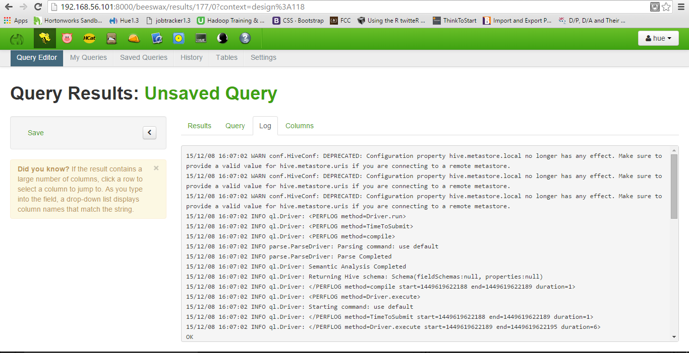

Snapshot: HIVE Table containing tweets loaded from the json files stored in HDFS

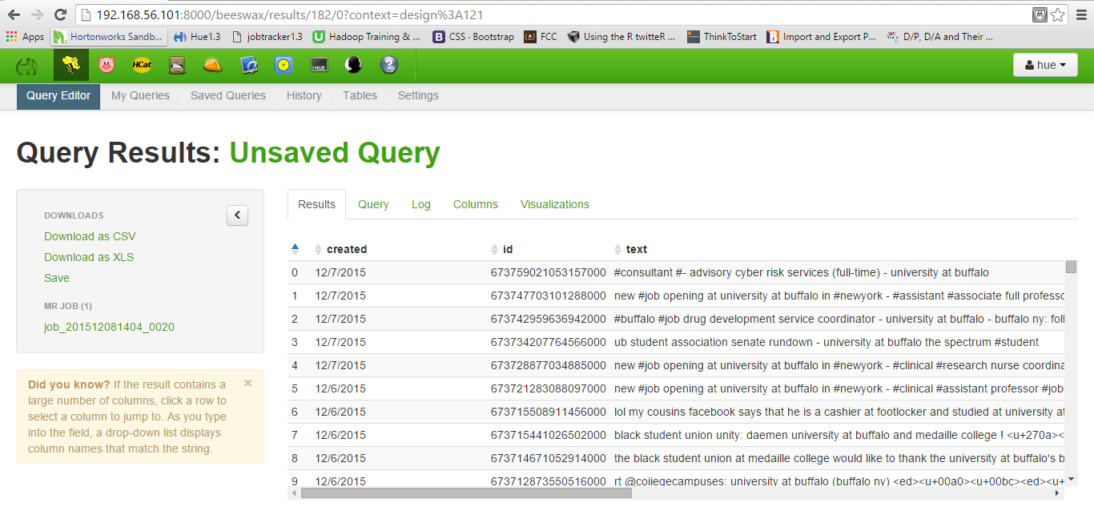

Snapshot: HIVE query to form an array from the words contained in the text of a tweet

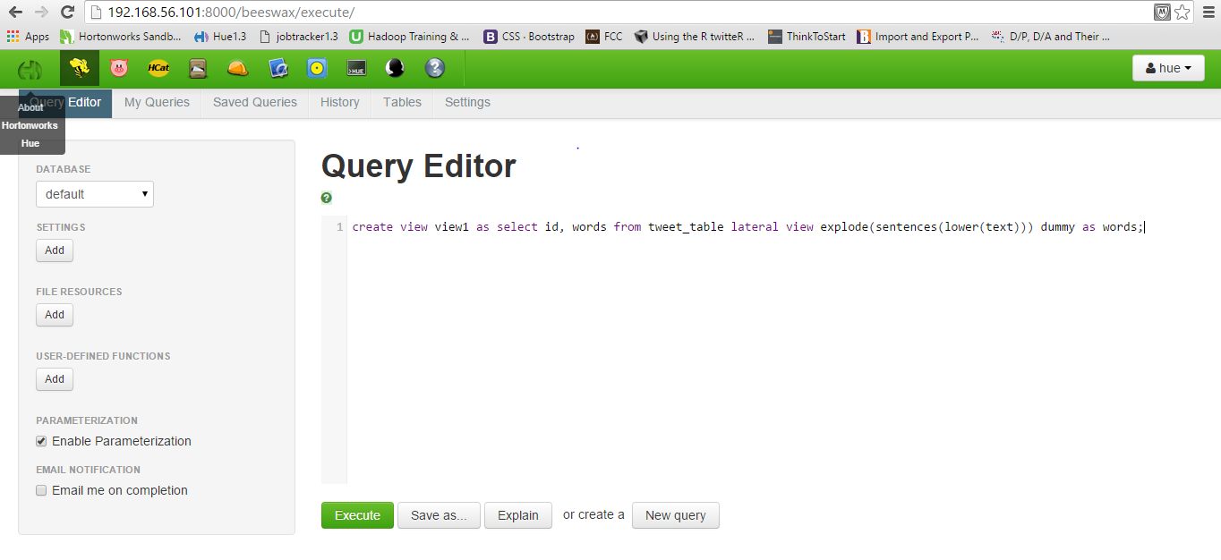

Query result:

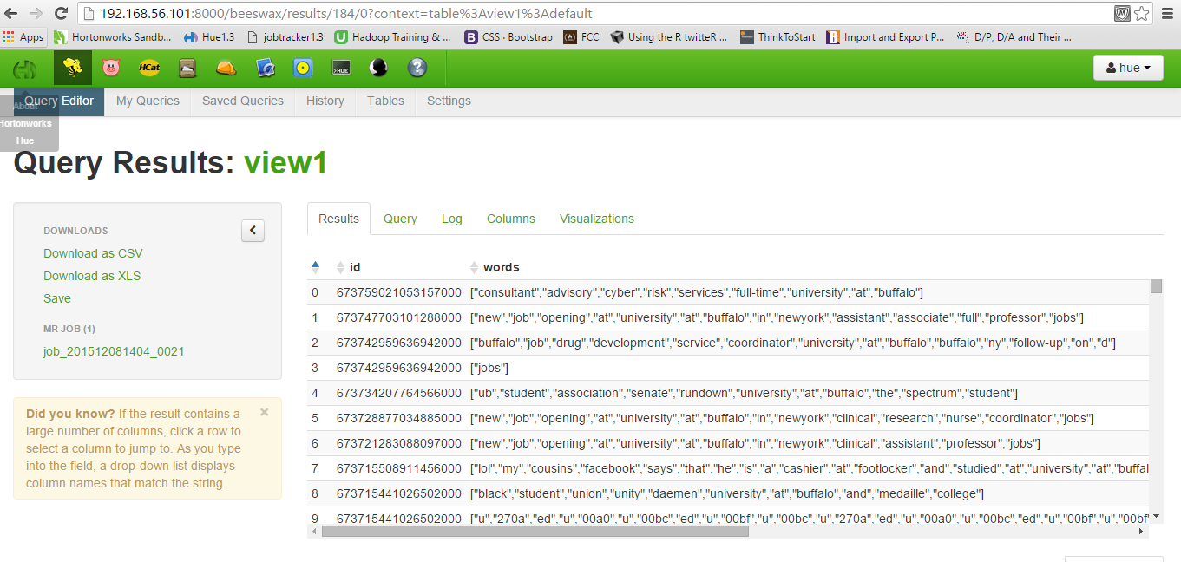

Snapshot: HIVE query to split the array into words and keeping those words mapped to the id of the original tweet

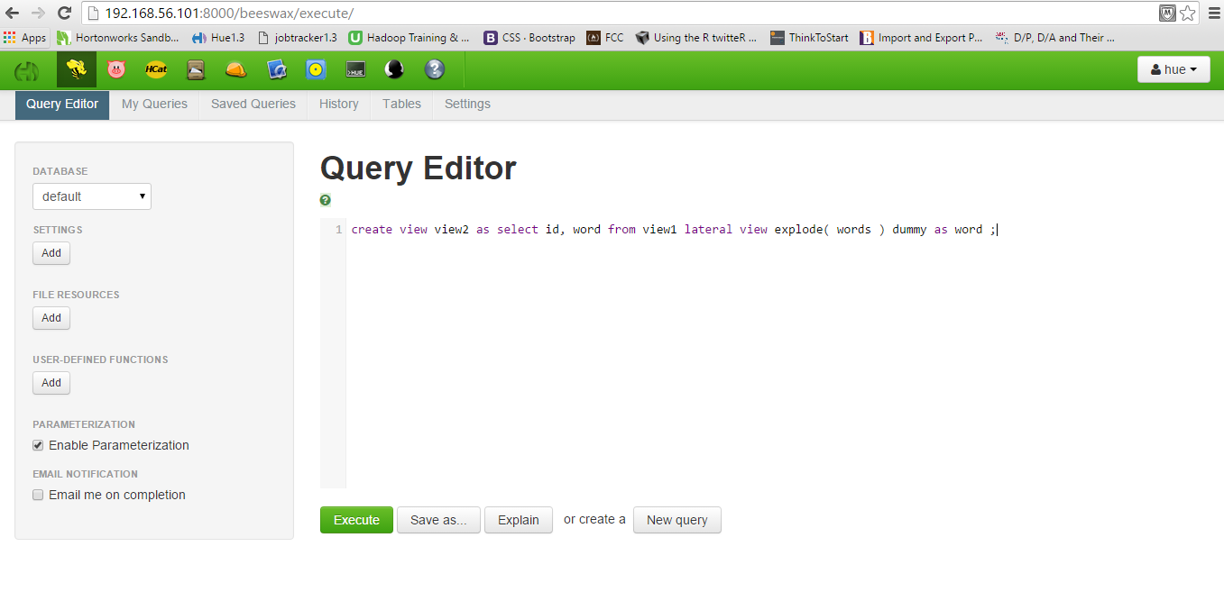

Query result:

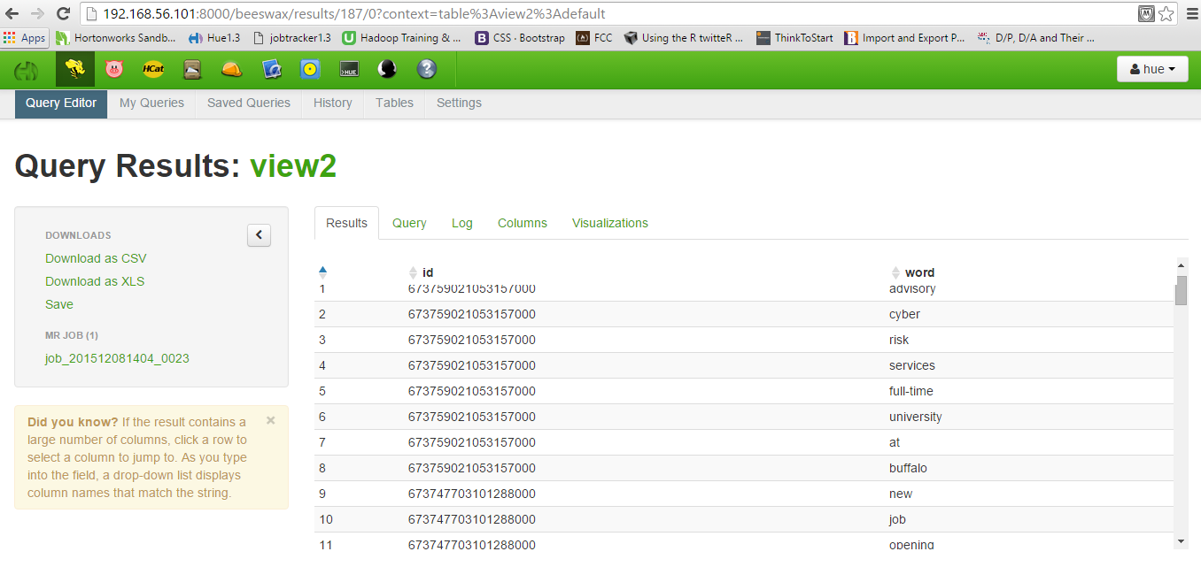

Snapshot: Query to assign a polarity to each of those words

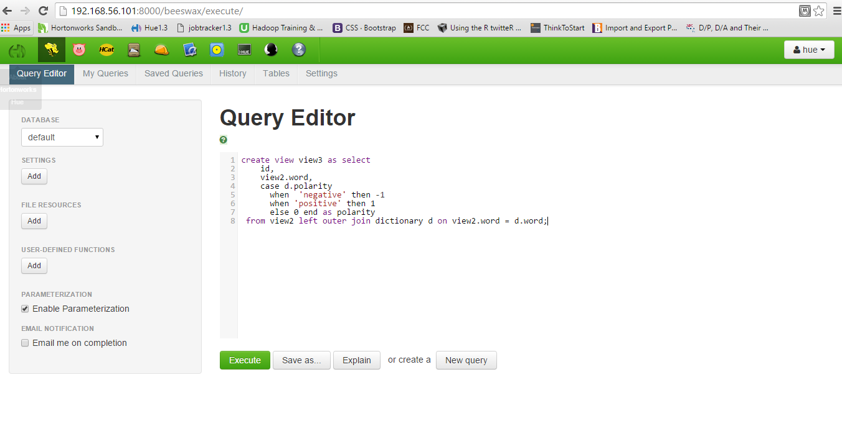Query result: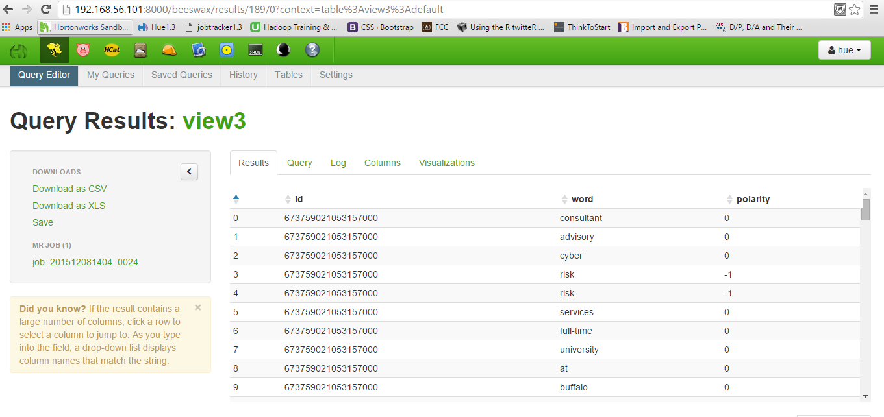

Snapshot: Collating the ‘polarity’ by ‘id’ and loading it into table sentiment_score and assigning the values positive, negative and neutral into ‘sentiment’ column

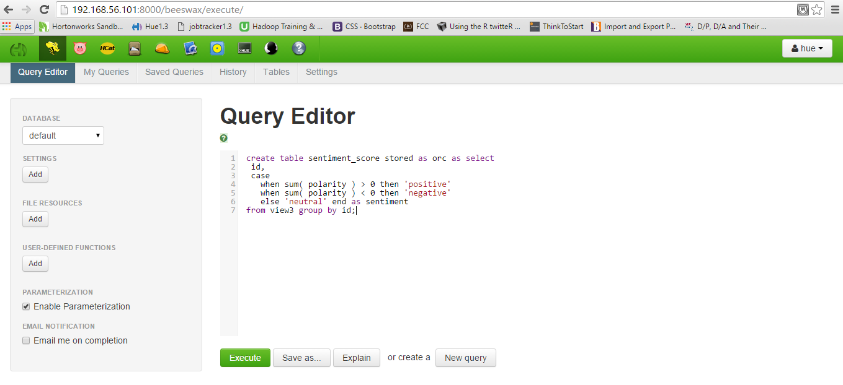

Query result:

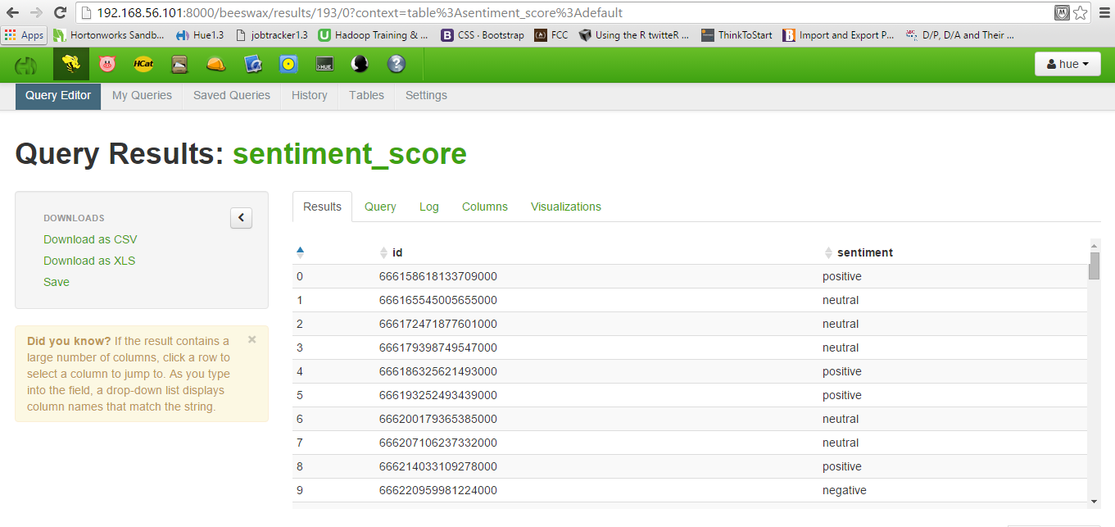

Snapshot:

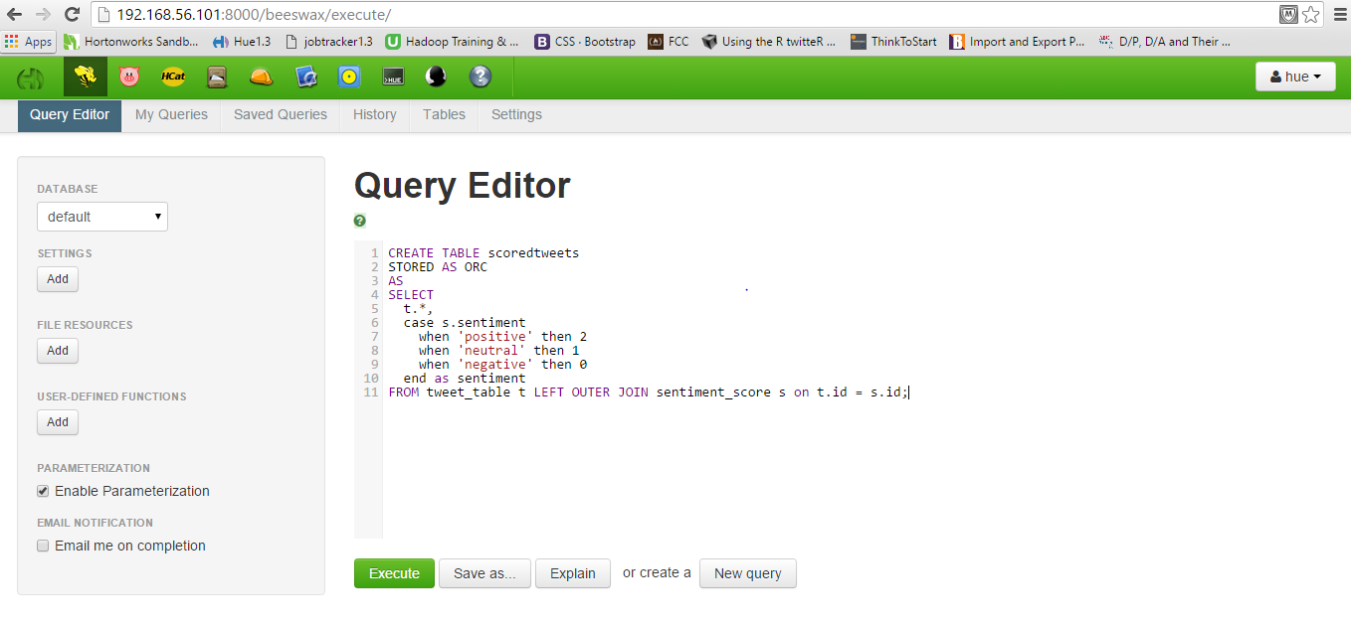

Final data downloaded as an xlsx file:

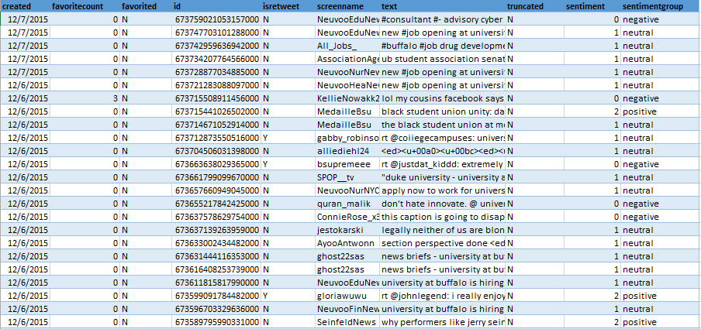

Visualizations using Powerview:

